Table des matières
Getting Started with PrimeReact 1
How to use PrimeReact in React Applications December 7, 2021 1

Getting Started with PrimeReact
https://www.youtube.com/watch?v=Prz3phy2bHY&ab_channel=Docstring
https://codesandbox.io/examples/package/primereact

How to use PrimeReact in React Applications December 7, 2021
https://www.section.io/engineering-education/using-prime-react-in-react-applications/

Installation classique d'une application react:
npx create-react-app my-prime
cd my-prime
npm start

Ajouter les dépendances primereact:
Pour installer les prime icons:
npm install primereact primeicons --save
La librairie prime react a besoin de prime icons et de react-transition-group.
npm install react-transition-group
npm install react-router-dom

Infos sur les icones : Icons (primefaces.org)
menubar : PrimeReact - React UI Component Library (primefaces.org)
thèmes : Getting Started - PrimeReact (primefaces.org)

Getting Started with PrimeReact
https://www.youtube.com/watch?v=Prz3phy2bHY&t=1s&ab_channel=CagatayCivici

Installation classique d'une application react:
npx create-react-app prime-app
cd prime-app
npm start

Ajouter les dépendances primereact:
Pour installer les prime icons:
npm install primereact primeicons --save
npm install react-transition-group --save

Ajouter dans App.js:
import "primereact/resources/themes/lara-light-indigo/theme.css"; //theme
import "primereact/resources/primereact.min.css"; //core css
import "primeicons/primeicons.css"; //icons

cf https://www.primefaces.org/primereact/inputtext/
import { InputText } from 'primereact/inputtext';

import {useState} from 'react';

const [text, setText] = useState();

Two way binding:
<InputText value={text} onChange={e => setText(e.target.value)}/>
{text}

(8:44) Ajouter un bouton :

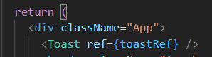

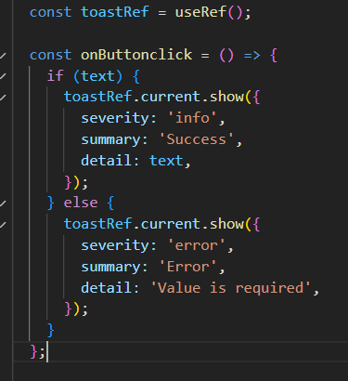

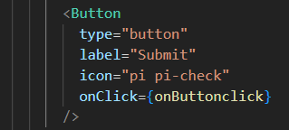

(16:40) FloatLabel
https://www.primefaces.org/primereact/floatlabel/

